🐋

Humpback Whale Teachers Toolkit (Primary)
Ocean Life Education – Classroom Resource
(see supporting imagery at foot)

🌊 Key Humpback Whale Facts
✅ Humpback whales migrate between Antarctica and Queensland each year
✅ They can travel over 10,000 km
✅ Migration season: May–November (East Coast Australia)
✅ Calves are born in warm waters for protection
✅ Whales communicate using complex songs

🗺️ Activity 1: Migration Mapping

📌 Task
Label a map showing:
- Feeding grounds (Antarctica)
- Breeding grounds (Queensland)
- Migration route

⭐ Extension Challenge
Add:
- Ocean currents
- Water temperature zones

🧬 Activity 2: Whale Anatomy Labelling

📝 Label the diagram
- Blowhole
- Fins (flippers)
- Tail flukes
- Baleen plates
- Blubber

✏️ Explain the function
Feature | Function
Blowhole | __________________________
Fins | __________________________
Tail flukes | __________________________
Baleen plates | __________________________
Blubber | __________________________

✅ Teacher Answers
- Blowhole → breathing
- Fins → steering and movement
- Tail flukes → propulsion
- Baleen plates → filter feeding
- Blubber → insulation + energy storage

✏️ Activity 3: Creative Writing – Whale Diary
Write a diary entry from a migrating humpback whale.
Include:
- 🌍 Your journey
- ⚠️ Challenges you face
- 🌊 What you see along the Queensland coast
👉 Starter sentence:
"Today I began my long journey from Antarctica…"

🧠 Humpback Whale Quiz
- How far can humpback whales migrate each year?
- Between which regions do humpback whales travel?
- When is the migration season in Australia?
- Why are calves born in warm waters?
- What is whale song used for?
- How do baleen plates help whales feed?
- What is the function of blubber?
- Why do whales migrate long distances?
- What challenges do whales face during migration?
- How can humans help protect whales?

✅ Quiz Answers (Teacher Use)
- Up to ~8,000 km+
- Between cold feeding and warm breeding areas
- April–November
- Warm water helps calves survive
- Communication + mating
- Filters food from water
- Insulation + energy storage
- Feeding + reproduction
- Distance, predators, human impacts
- Reduce pollution, protect oceans

RESOURCES
Facts

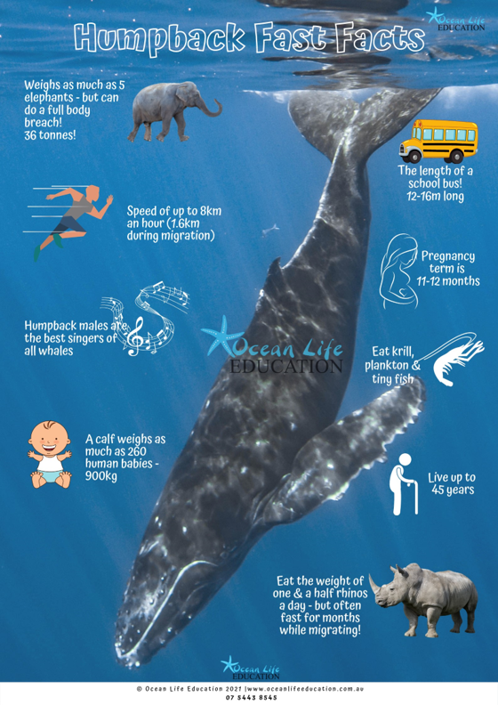

Migration Map
